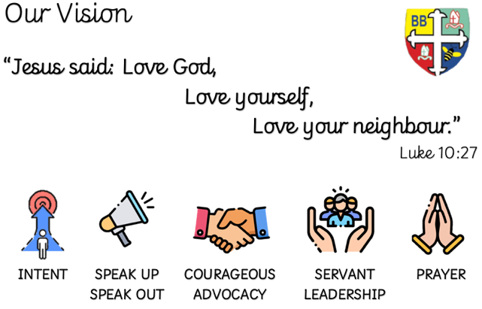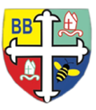Bishop Bridgeman Primary School – We Work, We Play, We Care, We Pray

@BishopBridgeman

**Class Routines**

Please ensure your child has their book bag in school every day. It is really important that your child reads every night, even if only for 10 minutes. Snack money is due every Monday. If you would like your child to have snack please send in £1 each Monday. Thank you for your continued support.

**Homework**

Homework will be set on seesaw every Friday. Please ensure your child is able to log on and complete their tasks each week. Seesaw logins will be given in the next week.

**RE**

This term we will be learning about harvest, what it is, why we celebrate and who we give thanks to. We will also be learning about rules, consequences of breaking rules and how God rescued people from the ‘Fall’ with the 10 commandments.

**Computing**

This term in Computing we are focusing on the topic ‘Online Safety’. Themes covered include self-image & identity, online relationships and health & well-being. There will be lots of activities and discussions to ensure the children are well equipped to stay safe online.

**PE**

PE is on a Monday and Friday. This term in PE we will be learning about fundamental movements. We will be learning new skills and developing old ones. Please ensure your child has a full PE kit in school at all times.

**Science**

This term we will be learning about rocks. We will find out about the different types of rocks, their properties and how they can be grouped.

**Topic**

This term in geography we will be learning about Spain. We will find the location of Spain on a map and know some of the cities and rivers that flow through the country. We will look at the culture of the country through festivals and traditions and also the sustainability of the country through its produce.

**Maths**

This term in Maths we will be learning about number and place value. We will be recognising the place value of each digit in a number, including HTO. We will be learning our timestables, consolidating 2, 5 and 10s and then progressing onto others.

**English**

This term in English we will be completing a reciprocal read of The Tin Forest, using our imagination to understand the text and write our own narratives. This term we will also move onto Year 3 spelling. patterns.

Year 3 Half Termly Newsletter September 2022