A Warm Welcome to

The Early Years Foundation Stage

at

Bishop Bridgeman CE Primary School



**Welcome to Bishop Bridgeman CE Primary School**

We welcome you and your child to our Early Years Foundation Stage {EYFS} Unit. Starting school is an important and exciting time for you and your child. Our aim is to ensure your child settles into his/her new surroundings as quickly as possible, and feels secure and happy whilst in our care. We hope that their time with us is happy and fulfilling.

As Parents/Carers, you are the child’s first educators and the home influence remains important throughout your child’s schooling. We therefore extremely value our relationship with you as an informative partnership in your child’s education. We aim to build on this relationship through our open door policy, notice boards, school events, parent’s post box and regular meetings.

We aim to provide your child with the best possible foundation to their education during their stay in our Nursery and Reception classes. We will deliver this through a friendly, caring and stimulating environment that will excite and motivate their learning.

In this booklet you will find useful information about the EYFS unit and if you have any questions please do not hesitate to contact us.

We look forward to working with you and your child in the coming months.

Mrs Ogden

EYFS Lead

|  |  |  |  |
| --- | --- | --- | --- |
| Introducing the Early Years Team | | | |
|  | | | |
|  |  |  |  |
| Mrs Ogden  EYFS Lead  Reception 2 Class Teacher | Miss Ryan  Reception 1 Class Teacher | Mrs Simjee Teaching Assistant with Reception 1 | Miss Mercer  Teaching Assistant with Reception 2 |
|  |  |  |  |
| Mrs Little  Nursery Class Teacher | Mrs Munshi  Teaching Assistant in Nursery | Mrs Khan  Teaching Assistant in Nursery |

Contact Details:

School office: 01204 333466

Miss Ryan – Reception 1: ryans@bishop-bridgeman.bolton.sch.uk

Mrs Ogden – Reception 2: ogdenz@bishop-bridgeman.bolton.sch.uk

Mrs Little – Nursery: littlel@bishop-bridgeman.bolton.sch.uk

Uniform

All children in the Early Years unit are expected to wear the school uniform. The school uniform list is:

* Grey trousers, skirt or jogging trousers {It is easier for the children if these things are elasticated. Young children find it very difficult to handle zips, belts and tights, so please select carefully}
* White polo shirt
* School sweatshirt or cardigan {with or without the logo}
* Black school shoes {trainers will not be permitted}

|  |  |  |
| --- | --- | --- |
|  |  |  |

Other Clothing

* There are a wide range of activities in the Nursery and Reception Classes and some of them are messy! They are an important part of the curriculum and necessary for your child’s education. Aprons are provided but please ensure your child has a named spare set of clothes on their peg.
* As part of the curriculum children will have access daily to our outdoor area. Your child will need a waterproof coat with a hood. They will require sun hats and sun cream in the summer.
* All children require a school book bag which will help them to carry reading books, home challenges and letter to and from school.

PLEASE NAME ALL OF YOUR CHILD’S BELONGINGS, INCLUDING SHOES!

Snacks

We are fortunate to receive free fresh fruit and milk each day. In addition to this we offer a range of other healthy snacks to provide choice for your child such as breadsticks, crackers, hot toast etc. To help cover the cost of the additional snacks we do ask for a contribution of £1.00 per week. This money helps to pay for baking ingredients, messy play equipment, as well as snacks. You can pay this for the half term / term if you prefer.

Your child will need a water bottle with their name on, sent each morning with fresh water. Juice is not permitted.

Lunch at School

Children in Reception are entitled to a hot lunch each day, funded by the government. The adults help each child to choose their lunch each day.

Safety

Our top priority is to provide as safe an environment as possible for your child. You can help with this in a number of ways:

* Provide your child’s class teacher with a password. This is to make sure your child is always handed over to a safe adult at the end of the day.
* Let us know if there are any changes to the person who usually picks up your child. If it is an emergency or you only find out at short notice then please telephone the school office. Any new adults will need the password.
* Provide us with at least two emergency contact numbers and let the school office know straight away if they change.
* Children are collected from the KS1 yard if they are an only child or the KS2 yard if they have siblings. A teacher will be there at 8.55am and 3.20pm.
* All children must be brought to and collected from school by someone 16 or older.

The School Day

Nursery:

Our school day starts at 8.30am and the end of day collection is 11.30am for children attending a morning session. Children arriving late will not be admitted until 8.55am as the teachers will be teaching the first lesson of the day. The afternoon session starts at 12.30pm until 3.30pm. Safety is our priority so please be patient and do not shout your child. We will say the child’s name when we see you, this way we know each child has gone home with the correct adult.

Reception:

Our school day starts at 8.55am and the end of day collection is 3.20pm.

At the beginning of the school day all children come to school through the classroom doors and collection at 3.20pm is from either the KS1 or the KS2 yard. We will provide more information about this in September. Safety is our priority so please be patient and do not shout your child. We will say the child’s name when we see you, this way we know each child has gone home with the correct adult.

The EYFS Framework

What will my child be learning?

The Nursery and Reception Classes are where we provide your child with the best possible foundation to their education. They EYFS caters for children between the ages of 3-5 years.

The curriculum organises itself into ‘Areas of Learning’ rather than subjects. There are seven areas of learning. Three prime areas and four specific areas.

Prime Areas

Personal, Social and Emotional Development

These experiences provide children with skills which will help them to develop a positive sense of themselves and of others; respect for others; social skills and a positive disposition to learn.

|  |  |
| --- | --- |
|  |  |

Communication and Language

We support and extend children’s learning and competence in communication by speaking and listening. We will provide them with opportunity and encouragement to use their skills in a range of situations and for a range of purposes. We support them in developing the confidence to speak clearly.

|  |
| --- |
|  |

Physical Development

We will encourage their physical development through the provision of opportunities for them to be active and interactive and to improve their skills of co-ordination, control manipulation and movement. They will be supported in using all of their senses to learn about the world around them and to make connections between new information and what they already know. We will help them to develop an understanding of the importance of physical activity and making healthy choices in relation to food.

|  |  |  |
| --- | --- | --- |
|  |  |  |

Specific Areas

Literacy:

Literacy involves encouraging children to read and write both through listening to others read and being encouraged to being to read and write themselves. We will give your child access to a wide range of reading material, such as books, poems and other written materials to ignite their interests.

|  |  |  |  |
| --- | --- | --- | --- |
|  |  |  |  |

There are many enjoyable activities we provide that will develop your child’s early writing skills:

|  |  |  |  |  |  |  |
| --- | --- | --- | --- | --- | --- | --- |
| * Paint | * Chalks | * Crayons | * Sand | * Plasticine | | * Shaving foam |
| * Flour | * Gloop | * Custard | * Soil and sticks | | * Finger painting | |

If your child shows an interesting in writing their name please model it for them with a capital letter at the start.

If they want to write, please show them letters like this:

Faizan, Lana **NOT: FAIZAN, LANA**

|  |
| --- |
|  |

Mathematics

Mathematical development involves providing children with opportunities to practice and improve their skills in counting numbers, calculating simple addition and subtraction problems, to describe shapes, spaces and measures. Our environment is enriched with a range of opportunities for your child to become a brilliant problem solver.

Maths is everywhere around us, so young children will naturally meet

activities every day. Here are some examples:

* Laying a table
* Playing with water
* Tidying away the toys
* Baking
* Shopping
* Sorting and counting
* You can sort by colour, shape, size using everyday items such as buttons, biscuits, socks and sweets.

Understanding the World

Understanding the world involves guiding children to make sense of their physical world and their community through opportunities to explore, observe and find out about people, places, technology and the environment.

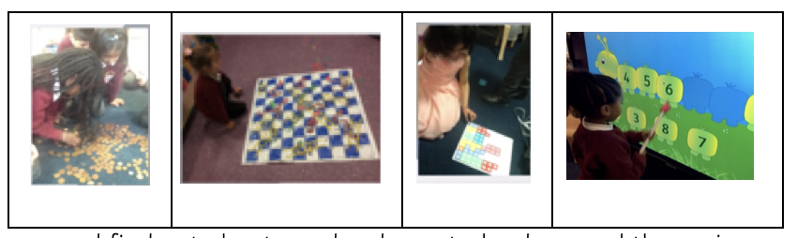

|  |  |
| --- | --- |
|  |  |

Expressive Arts and Design

We will extend your child’s creativity through support of their curiosity, exploration and play. They will be provided with opportunities to explore and share their thoughts, ideas and feelings for example, through a variety of art, music, movement, dance, imaginative and role play activities.

|  |  |  |
| --- | --- | --- |
|  |  |  |

It is important that children know how to learn just as much as what to learn. They learn best by doing. They need first hand experiences and learning that makes sense to them. In fact, they learn best through play.

“Play is work, work is play”.

Can your child?

The following self-help skills will increase independence:

* Use the toilet, clean themselves and flush the toilet
* Wash hands
* Fasten his/her coat, and hang it up
* Use a knife and fork
* Use a tissue
* Tidy toys away
* Fasten his/her shoes
* Share toys, books and take turns
* Say and recognise his/her name

Talking and Listening

* Talk encouragingly about school.
* Include your child in conversation.
* Show an interest in what they are doing and share your interests with them.
* Listen to your child and make sure your child listens to you.

Reading

* Please try to teach your child how to look at a book and treat it with respect.
* Encourage his/her eyes to look from left to right.
* Point to the written word from time to time and talk about the illustrations.
* Read and share books with your child regularly.

|  |
| --- |
|  |

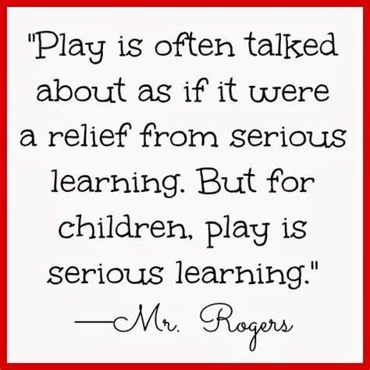

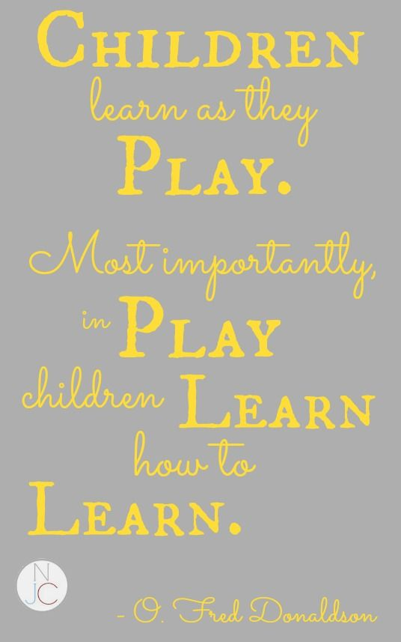

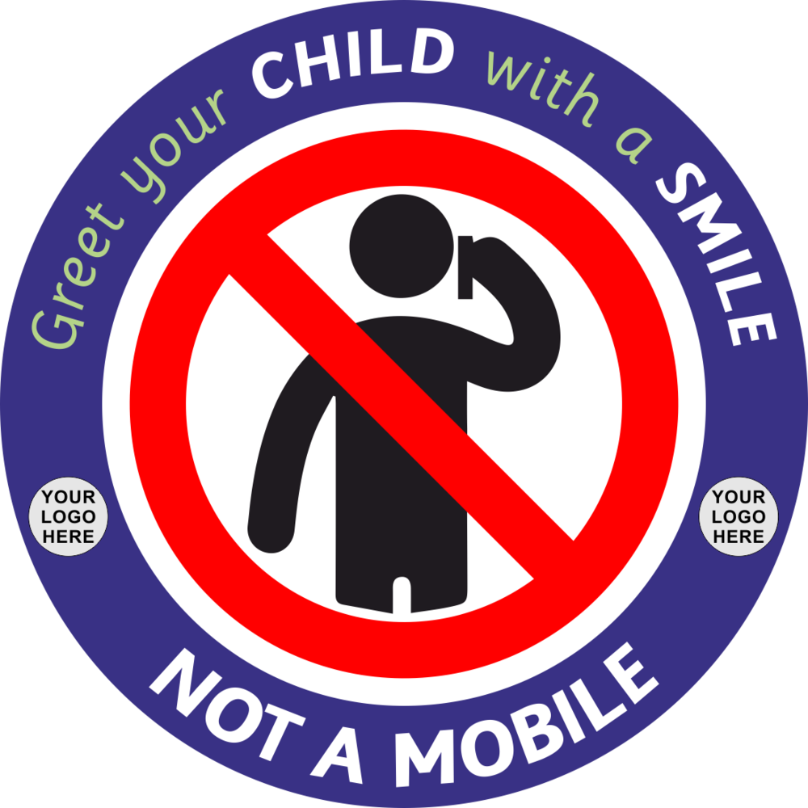

‘We ask that you leave your telephone in your pocket when collecting your child. This is for their safety and their wellbeing; they have missed you and want to know that you’ve missed them, too’

Keeping in Touch

In addition to contacting the school office on 01204 333466, you can contact your child’s class teacher on the email address below.

Miss Ryan – Reception 1: ryans@bishop-bridgeman.bolton.sch.uk

Mrs Ogden – Reception 2: ogdenz@bishop-bridgeman.bolton.sch.uk

Mrs Little – Nursery: littlel@bishop-bridgeman.bolton.sch.uk





Search ‘EarlyYears FoundationStage BishopBridgeman’