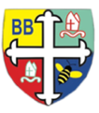

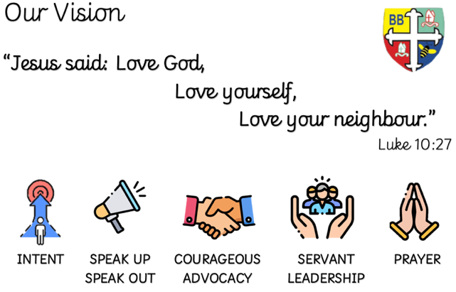Bishop Bridgeman Primary School – We Work, We Play, We Care, We Pray

**PE**

This term in PE we will be developing team work, listening and following instructions – we will do this by playing games using cones, balls and hoops. We also have a weekly session with our dance teacher. We will be practising moving to the beat as well as warming up and cooling down our bodies. Children in reception will need a PE kit, week beginning 19th September.

**Computing**

This term in Computing we are learning to use the iPads independently- we will be playing phonics and maths games. There will be discussions to ensure the children are well equipped to stay safe online.

**RE and Worship**

This term we will be learning about the bible and special books. We will learn about special places of worship for Christians.

**Notices**

* **Snack money** is £6 for this half term.
* Please send your child with a **book bag** each day.
* **Water bottles** – please send your child with fresh water every day.
* **Attendance** is so important – please help reception increase our percentage by sending your child every day unless they are unwell. A child with a sniffle is welcome in school – we have tissues and sanitiser.

**Important Notice**

**We have a child in Early Years with a nut allergy. Please support us in being ‘nut free’. This means no Nutella on sandwiches in packed lunches, no sesame seeds and no nuts of any kind. Thank you for your support with this.**

Please feel free to speak with your child’s class teacher if you have any questions about anything.

**Home Challenges**

Challenges will be set on Seesaw every Friday. Please support your child in completing their tasks each week.

**Understanding the World**

This term we will be looking back to when we were babies so we can create a class book. We will also be talking about our families – we will be sending a letter home to ask for photographs.

**Maths**

This term in Maths we will be introducing White Rose Maths. We will be counting, sequencing and exploring numbers to 5. We will send home challenges – please check Seesaw regularly.

**Literacy**

This term in Literacy we will be listening to stories and thinking about the characters. In Phonics we will be assessing the children and starting phase 2. We will send more information next week about a phonics and reading workshop.

@EarlyYears FoundationStage

BishopBridgeman

Reception Half Termly Newsletter September 2022