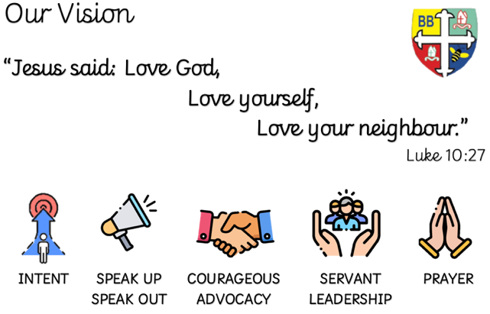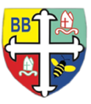Bishop Bridgeman Primary School – We Work, We Play, We Care, We Pray

@BishopBridgeman

**Class Routines**

Please ensure your child has their book bag in school every day. It is really important that your child reads every night, even if only for 10 minutes. Snack money is due every Monday. If you would like your child to have snack please send in £1 each Monday. Thank you for your continued support.

**Homework**

Homework will be set on seesaw every Friday. Please ensure your child is able to log on and complete their tasks each week.

**RE**

This term we will be learning about the bible and special books.

**Computing**

This term in Computing we are focusing on the topic ‘Online Safety’. Themes covered include self-image & identity, online relationships and health & well-being. There will be lots of activities and discussions to ensure the children are well equipped to stay safe online.

**PE**

This term in PE we will be learning about fundamental movements and gymnastics. Please ensure your child has a full PE kit in school at all times.

**Science**

This term we will be learning about materials. We will identify different materials, look at their properties and find out their suitability.

**Topic**

This term in history we will be learning about William Hesketh Lever. We will find out all about his life and his legacy. William Lever was famous for the bars of soap that he made called sunlight soap. In DT we will be designing and making our own structures to hold bars of soap just like William Lever designed.

**Maths**

This term in Maths we will be learning about number and place value. We will be counting forwards and backwards up to 100. We will be counting in 2s, 5s and 10s and we will be looking at the value of numbers to 100, identifying how many tens and ones a number has.

**English**

This term in English we will be completing a Talk for Writing sequence of learning about a journey story. In Phonics we will be recapping phases 4 and 5. This term we will also move onto Year 2 spelling patterns.

Year 2 Half Termly Newsletter September 2022